Week -5 PAYMENT AND TRANSACTION SYSTEM
Objective
To design and implement a Payment Transaction Module integrated with the existing Customer and Order Management modules for a beauty products e-commerce platform. This involves table creation, handling integrity constraints, recording transactions, managing statuses, and generating business analytics reports.
1. Database Schema & Setup
Two core relational tables were created to manage orders and payment transactions with primary and foreign key constraints:
- Beauty_Orders Table: Stores order references and associated customer identifiers.
- Beauty_Payment Table: Stores payment metadata, transaction dates, modes, statuses, and amounts.
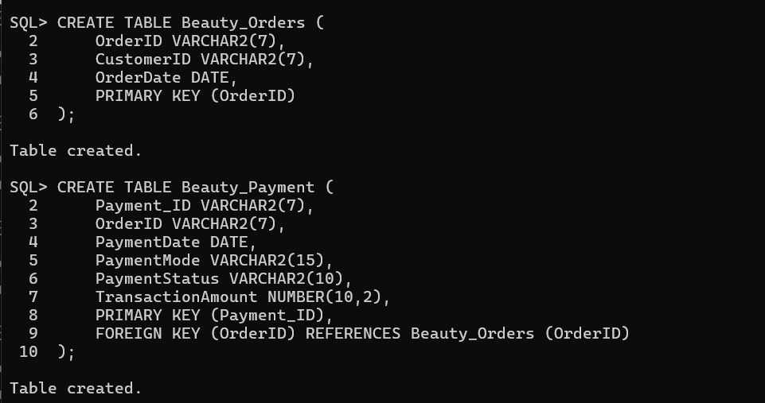
2. Data Population
Sample data representing customer cosmetic/skincare purchases were inserted into both tables:
- Orders Inserted: ORD0001, ORD0002, ORD0004, ORD0006, and ORD0008.
- Payments Inserted: PAY0001 through PAY0005 covering Credit Card, UPI, Debit Card, Net Banking, and Cash on Delivery (COD).
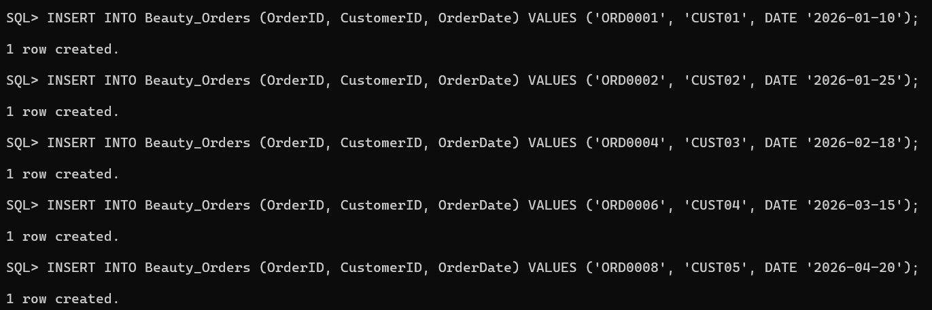
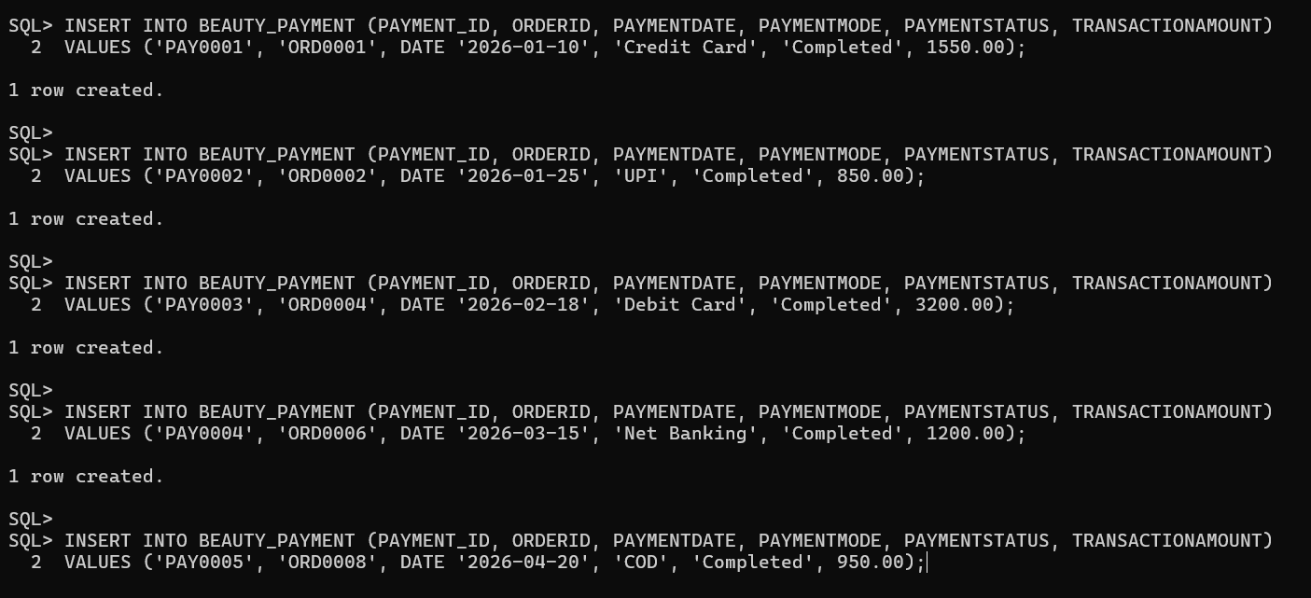
3. Data Verification
A SELECT * query was executed to verify that all inserted payment records are stored accurately.
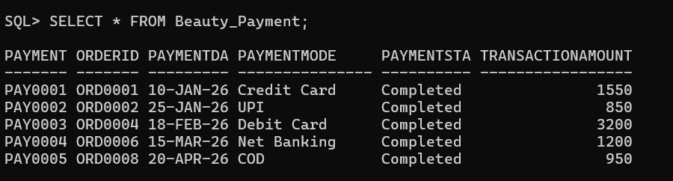

4. Managing Successful and Failed Transactions
Queries were executed to isolate transactions based on their current status and aggregate them by category.
- Display Completed Payments:
Result: All 5 recorded transactions (PAY0001 to PAY0005) returned successfully with a 'Completed' status.
- Find Failed Transactions:
Result: no rows selected (indicating zero failed transactions in the current dataset).
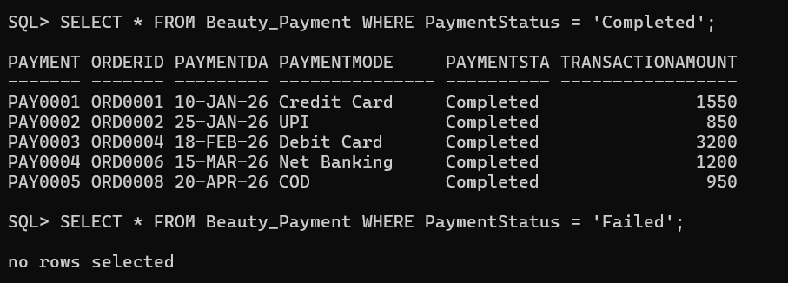
1.Count Total Successful and Failed Payments:
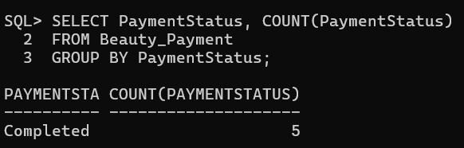
2.Payment Method Analysis
Specific filters were applied to measure customer channel adoption for digital wallets and card-based payment methods.
Number of UPI Transactions:
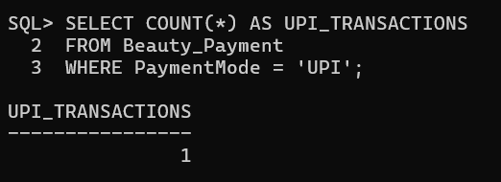
Result: 1 transaction.
3. Number of Card Payments (Credit/Debit):
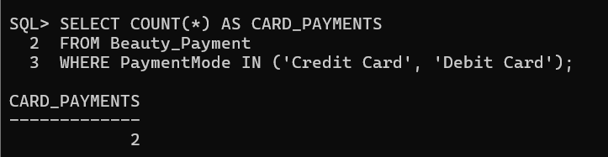
Result: 2 transactions (1 Credit Card, 1 Debit Card).
5. Payment Analysis & Business Reports
Report 1: Revenue Analysis
- Total Revenue Generated: 7,750.00.
- Average Transaction Amount: 1,550.00.
- Revenue Breakdown by Payment Method:
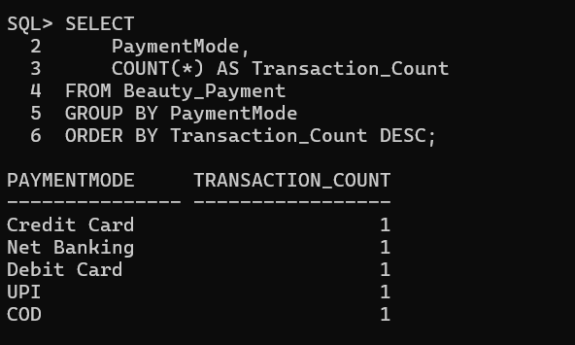
Report 1: Payment Mode Breakdown
- UPI Transactions: 1 transaction.
- Card Payments (Credit/Debit): 2 transactions.
- Most Preferred Payment Method: Determined using sorting and row filtering:
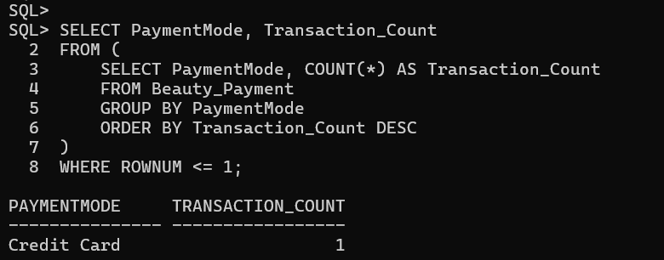
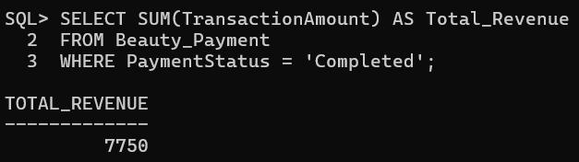
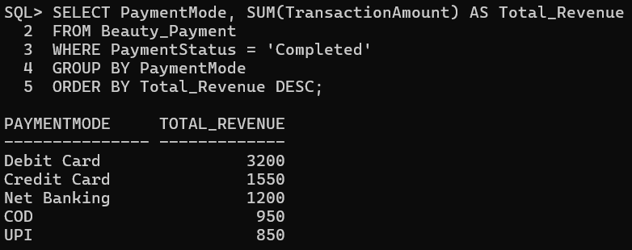
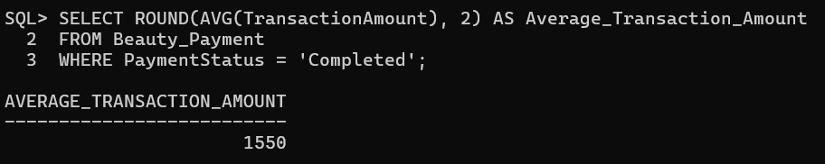
6. Customer Payment History Integration
A multi-table inner join query successfully mapped customer identities (Beauty_Customer), order logs (Beauty_Orders), and payment records (Beauty_Payment) to track end-to-end purchasing behavior chronologically.

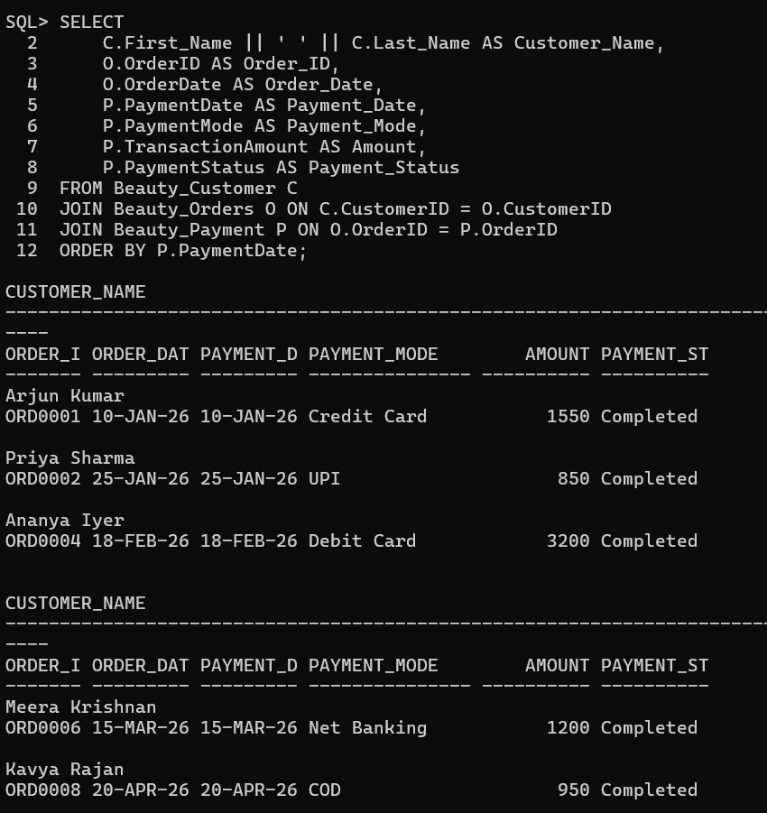

7. Comprehensive Summary Analytics Report
The final analytical report aggregates transaction frequency, gross revenue contribution, and average order value per payment mode for completed transactions:
